HS Civil Rights and Me for Lesson 2: Bullying/Cyberbullying/Online Safety

Objectives  - Students will be able to...  - Define bullying behavior in person and online and provide examples  - Identify strategies for online safety  - Demonstrate an awareness of other people's perspectives and a respect for individual differences.  - Identify ways to develop empathy toward victims of bullying | Materials Needed  - PowerPoint Presentation  - Post-it notes or half sheets of paper

Time | Description and Talking Points | PPT Slides
2-3 minutes | *See notes section on each slide of PowerPoint for detailed instructions. *  Objectives: what students will be able to do  Ask students to popcorn read, choral read or read to students | 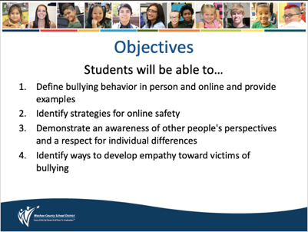
2-3 minutes | Working Agreements: These support students and teachers in creating a safe space for brave conversations  Read through the working agreements and clarify for students as needed.  As students to commit to these and lean into challenging conversations. | 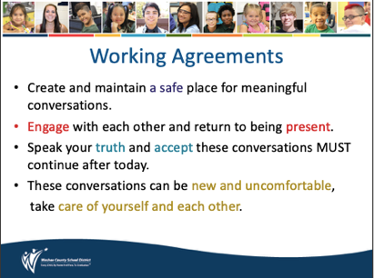
2-3 minutes | Optimistic Opener: This will help students connect with those around them and the work ahead.  Ask students to reflect on the quote and how it relates to bullying. | 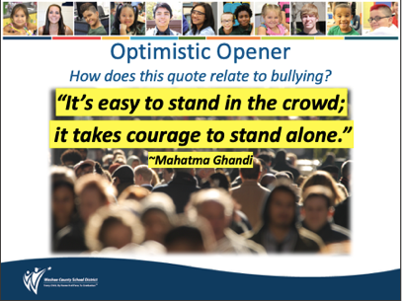
1-3 minutes | Engaging Strategies: Think-Turn-Tell  Read the question aloud “What does bullying mean to you?”  Think: 30 seconds of quiet reflection time  Turn – Tell: Share your ideas with a shoulder partner  Ask for students to share their responses with the class. | 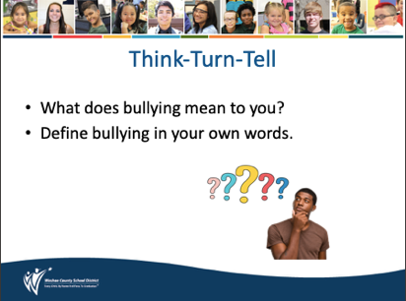
5-6  minutes | Key Vocabulary: Review  Ask students to popcorn read and define terms together.  Check for understanding with each term.  *See slide notes for digital learning adaptations | 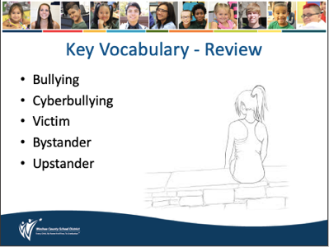
2-3 minutes | Key Vocabulary: Review  Emphasize to students…  - Bullying is intentional (done on purpose).  - Bullying is harmful (emotionally or physically)  - Words/Actions that are considered bullying are…  - Unwanted  - Repeated  - Creates a power imbalance | 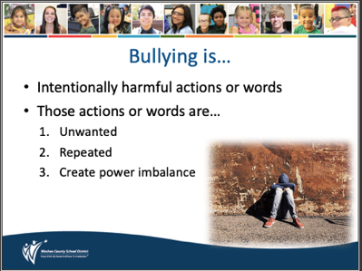
1-3 minutes | Key Vocabulary: Types of bullying  Explain the different types of bullying  Check for understanding and clarify as needed | 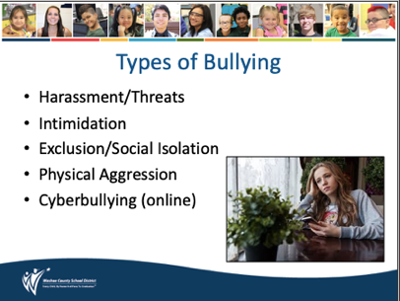
3-5  minutes | Key Vocabulary: Rude, Mean or Bullying  Students often confuse bullying with a mean or rude moment.  This slide clarifies the difference among the three.  Read to students OR have students popcorn read. | 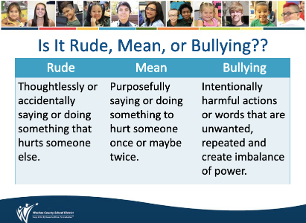
4-6 minutes | Engaging Strategies: Application  Students apply the definitions of RUDE, MEAN and BULLYING to decide which term best describes each example.  Allow students to work with a partner to come to a decision for each case  *See slide notes for digital learning adaptations | 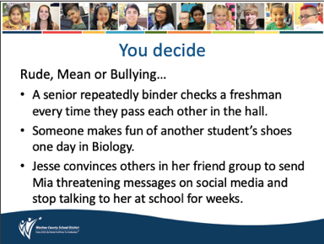
2-4  minutes | Brain Break: Help students refocus and practice building positive social norms by communicating appreciation for one another  Give 30 seconds to stretch and think of something they appreciate about their partner. Use the sentence stems (if desired) to share.  Ask students to reflect on how it feels to share appreciation  *See slide notes for digital learning adaptations | 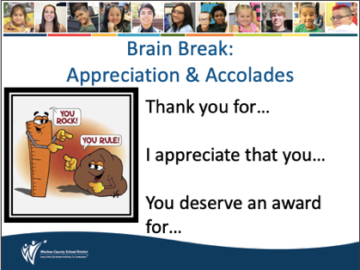
2-4  minutes | *Review section of lesson has ended, following content is all new*  Key Vocabulary: Social Norms  Review the features of SOCIAL NORMS– ask students to think about how social norms vary among the different communities to which they belong, (including in-person and virtual communities). | 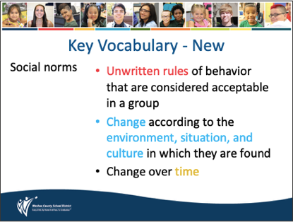
1-3 minutes | Key Vocabulary: Empathy, Acceptance and Inclusion  Clarify new terms  - Empathy – the ability to understand and share the feelings of another  - Acceptance – admitting someone to a group  - Inclusion – the act of including within a group | 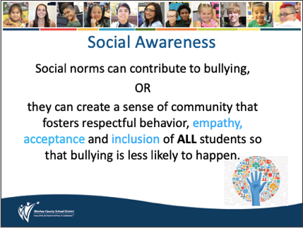
3 minutes | Engaging Strategies: Video Reflection  Click play to view the video  If you encounter technical problems:  - YouTube search: High school football players’ gifts to freshman who was bullied GMA  - Insert this URL in your web browser search bar: https://www.youtube.com/watch?v=_UNGgWtPT_I | 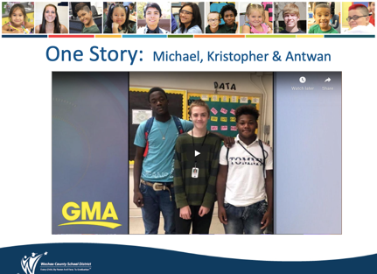
3-5 minutes | Engaging Strategies: 1:1:1 Partner Discussion – (Promoting equity of voice)  Allow 30 seconds for students to process the questions  Round 1 - Partner A speaks for one minute, starting with the question of their choosing – Partner B listens carefully without commenting​.  Reflection - How did it feel to be Partner A? B? What stood out to you?​  Round 2 - Reverse the roles  Reflection - How did it feel to be Partner A? B? What stood out to you?​  Round 3 – Both partners have a conversation for 1 minute  *See slide notes for digital learning adaptations | 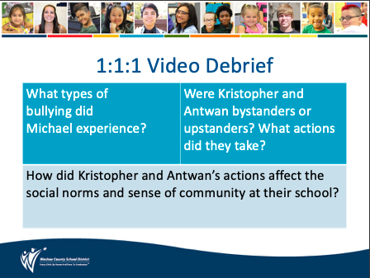
1-2 minutes | Working Agreements: These support students and teachers in creating a safe space for brave conversations  Revisit the working agreements to help ground students in these supports for the upcoming courageous conversations. Remember we want to empower students to trust in themselves and trust each other enough to speak openly and honestly. | 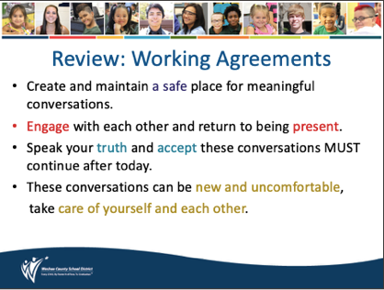
3-5 minutes | Engaging Strategies: 1:1:1 Partner Discussion – (Promoting equity of voice)  Allow 30 seconds for students to process the questions  Round 1 - Partner A speaks for one minute, starting with the question of their choosing – Partner B listens carefully without commenting​.  Reflection - How did it feel to be Partner A? B? What stood out to you?​  Round 2 - Reverse the roles  Reflection - How did it feel to be Partner A? B? What stood out to you?​  Round 3 – Both partners have a conversation for 1 minute  *See slide notes for digital learning adaptations | 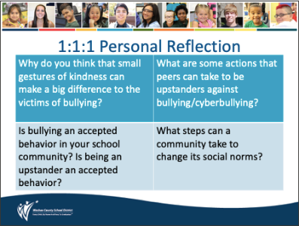
2-4 minutes | Reflective Closer:  Ask students to choose one of the two questions to answer on a half-sheet of paper or sticky note.  Take volunteers to share if time allows. Collect and review as students leave.  *See slide notes for digital learning adaptations | 